Setting up ionic project in mac

1. Firstly need to install Node.js

commands:

sudo apt-get update

sudo apt-get install nodejs

2. Install cordova:

$ sudo npm install -g cordova

3. Install ionic framework

sudo npm install -g ionic

4. Check installed ionic version

ionic -v

5. Create Your Project

ionic start HelloWorld blank

6. Add respective platforms android / ios

ionic platform add ios

7. Build the android app

ionic build ios

Publishing Ionic app(ios)

1. First, you need to enroll in [Apple Developer Program](https://developer.apple.com/programs/). As with Google, if you have a personal account with Apple, you can create an additional one for your applications.

2. **Connecting Xcode with your Developer account**

After you receive your developer status, open Xcode on your Mac and go to Preferences -> Accounts and add your account to Xcode by clicking the + button on the lower left hand side, and follow the instructions:

3. **Signing**

Now that you linked Xcode with your developer account, go to Preferences -> Accounts, select your Apple Id on the left hand side and then click the View Details button shown on the previous image. You should see the popup similar to the one on the image below:

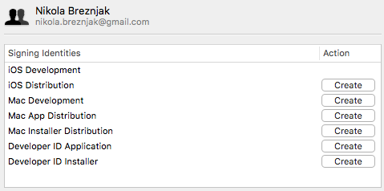

Click the Create button next to the iOS Distribution option

4. **Setting up app identifier**

Next, through the [Apple Developer Member Center](https://developer.apple.com/membercenter) we’ll set up the app ID identifier details. Identifiers are used to allow an app to have access to certain app services like for example Apple Pay. You can login to Apple Developer Member Center with your Apple ID and password.

Once you’re logged in you should choose Certificates, Identifiers, and Profiles

5**. Registering an app**

a) Give the app id dscription

b) mention the bundle id used for the build

**In our case we have used bundle id as : com.teamaxisengage.production**

You can cross check the bundle id in config.xml and chaange version number for every release

**<widget id="com.teamaxisengage.production" version="0.0.2" xmlns="http://www.w3.org/ns/widgets" xmlns:cdv="http://cordova.apache.org/ns/1.0">**

6. Go to **Myapps** in **itunes connect**

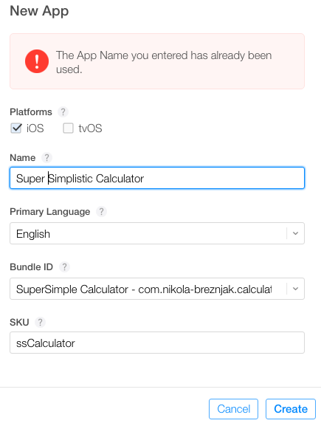

Once you’re done, click on the Create button and you’ll be presented with the following screen where you’ll have to set some basic options like Privacy Policy URL, category and sub category.

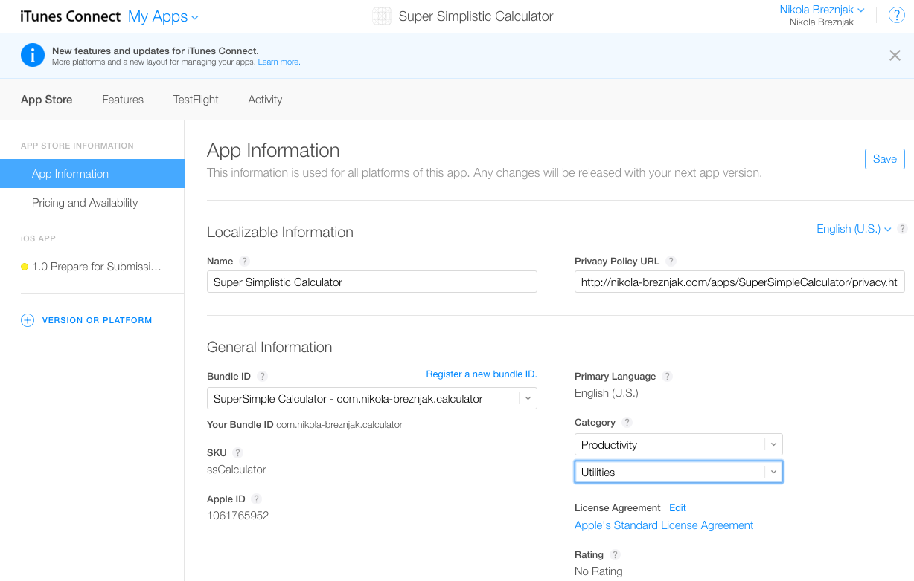

**Building the app for production**

In the root directory of your application execute the following command: ionic build ios --release

**Opening project in xcode:**

Now, open the platforms/ios/SuperSimpleCalculator.xcodeproj file in Xcode (of course you would change SuperSimpleCalculator with your own name).

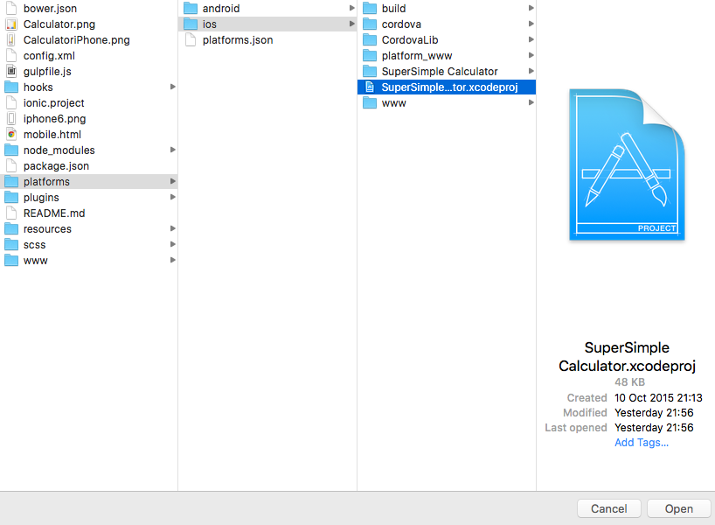

Once the Xcode opens up the project, you should see the details about your app in the general view, as shown on the image below:

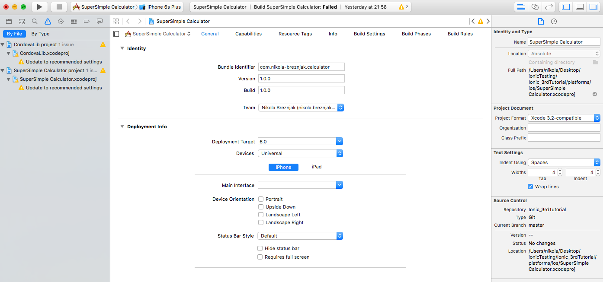

You should just check that the bundle identifier is set up correctly, so that it’s the same as the value you specified earlier in the app ID. Also, make sure that the version and build numbers are correct. Team option should be set to your Apple developer account. Under the deployment target you can choose which devices your application will support.

**Creating an archive of application**

In Xcode, select Product -> Scheme -> Edit Scheme to open the scheme editor. Next, select the Archive from the list on the left hand side. Make sure that the Build configuration is set to Release as shown on the image below:

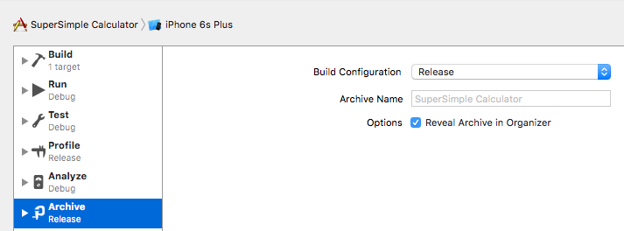

To create an archive choose a Generic iOS Device, or your device if it’s connected to your Mac (you can’t create an archive if simulator is selected), from the Scheme toolbar menu in the project editor,

Next, select Product -> Archive, and the Archive organizer appears and displays the new archive.

At this point you can click the Upload to App Store... button, and if everything goes fine you’ll have an uploaded app, and the only thing that’s left to do is to complete the iTunes Connect listing and submit it for review!

**Updating the app**

Since you’ll probably want to update your app at some point you’ll first have to update the build and version numbers in the Cordova config.xmlfile and then rebuild the application and open it up from the Xcode and follow the same steps all over again.

Once you submit for the review, you’ll have to wait for the review process again. It’s pivotal to note that if your changes aren’t too big you could use [Ionic Deploy](http://docs.ionic.io/docs/deploy-from-scratch) to update your application without going through the review process.

change the version number before updating in conig.xml

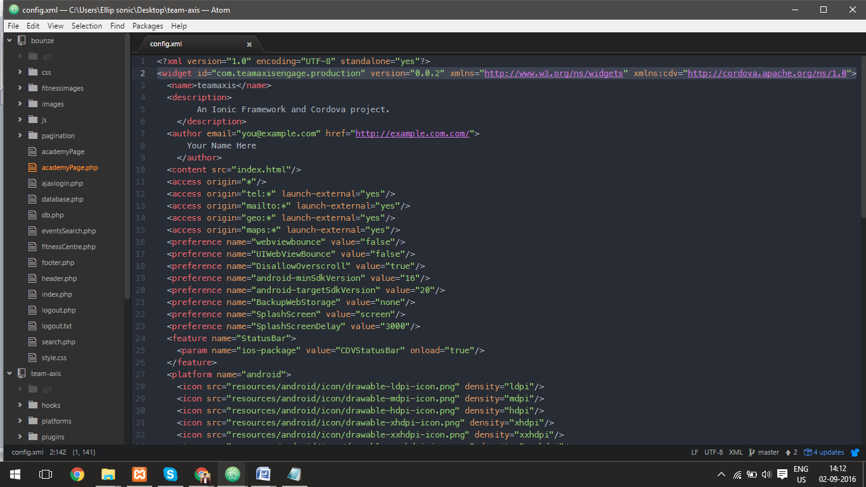

**References : http://ionicframework.com/docs/guide/publishing.html**